Disruption of Bacterial Genes Using Transposable Elements

MMG 408 Section 1

Devin Carree, Hai Truong, Keyur Patel

November 3, 2019

**Introduction**

There are many genes in the genome of every organism. There are over 5000 genes in the bacteria *P. putida*(1). If we can understand every one of these genes, we can understand how organisms build themselves up using only DNA and proteins. Now that we can sequence the entire genome of every organism, we are able to read the entire genetic makeup of many different organisms, but this is not enough. Although we may know the nucleotide code of the entire genome that does not allow us to completely understand the physical attributes (phenotype) of the protein that the gene encodes. To do this complex lab techniques must be performed. In this study we use transposable elements to disrupt a gene to study the phenotypic effects of this disrupted gene. We then use DNA sequencing and NCBI BLAST database to determine which gene is disrupted, the protein associated with it and its effect on the phenotype.

Many bacterial genes are used to allow organisms to metabolize different metabolites. Such as the Lac operon which allows the metabolization of Lactose. Another example of many genes that are transcribed and used for metabolization includes the mechanism used to metabolize Levulinic Acid (LA). LA is a carbon source that becomes available after a dehydration reaction of lignocellulosic biomass(2). LA can serve as the main source of carbon in some bacteria, yet we still do not know the complete mechanism that allows bacteria to metabolize the source. Although the entire mechanism may have not been identified, some researchers reported to have identified a 7-gene operon that enables the catabolism. In this study we hope to either verify the identification of one or all the genes in this operon or identify novel genes that are also associated with the catabolism of LA.

This study hopes to do this identification by using transposable elements or transposons to disrupt the gene, then using DNA sequencing to read the genetic location of the transposons to identify the disrupted gene. This ability for transposons to be incorporated into the genome of organisms have been implicated for a while. A 1953 study revealed changes in the genetic expression may results from chromosome alterations at the locus of a gene, introduced by “units” other than the gene itself. We know today that these “units” are known as transposons(3). This study uses the transposons ability to randomly incorporate itself into the genome of an organism in hopes that we will affect the organism’s ability to metabolize LA. We hypothesize that our transposon will be incorporated into the genome of bacteria producing a *Lev­*– mutant. We believe that the gene that will be interrupted will be essential for LA metabolization.

**Methods**

*Extraction of Bacterial Plasmid*

In this study we extracted the bacterial plasmid DNA containing our transposon. To this this we followed the experimental protocol(4).

*Incorporation of Plasmid into P. putida*

We used electroporation to allow introduction and integration of plasmid DNA to genomic DNA. To do this we followed the experimental protocol.

*Isolation of Lev – mutant chromosomal DNA*

We screened for mutants using a suicide vector, plasmid pSAM_DKm, and kanamycin antibiotics. We isolated the chromosomal DNA with the incorporated plasmid DNA and used PCR to amplify this area. We used gel electrophoresis to separate our DNA fragments to obtain the correct sequence. To do this we followed experimental protocol.

*DNA Sequencing*

We sequenced the DNA after isolation of the PCR product. To do this we followed the experimental protocol.

**Results**

In this study we were able to grow many mutants that were not able to grow on a medium of LA. The results of this lab include the viable bacteria that are able to grow on glucose medium plates but the same bacteria that is not able to propagate while contained in a medium containing only LA. We were able to take these bacteria and extract the genetic material to create PCR products. The size of this product was larger than the original size of the genomic chromosome. This is shown in figure 1.



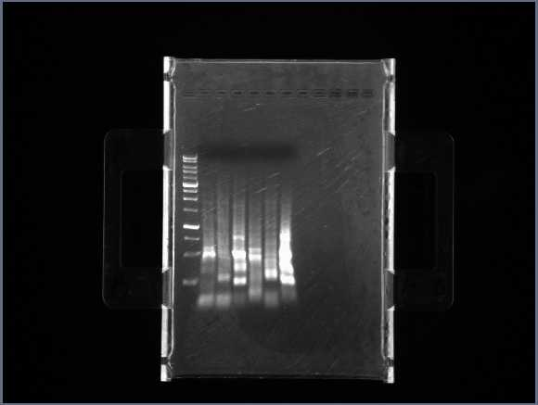



Fig 1. This figure shows the bacterial DNA after it has gone through a PCR. The activity shows that this band is larger than the original genomic DNA

We also determine the sequence of the DNA that is attached the transposon. Using the Chromas application we were able to read the DNA sequencing file that was sent off to obtain the sequence of the transposon and the flanking regions which would be our gene of interest. This is seen in figure 2

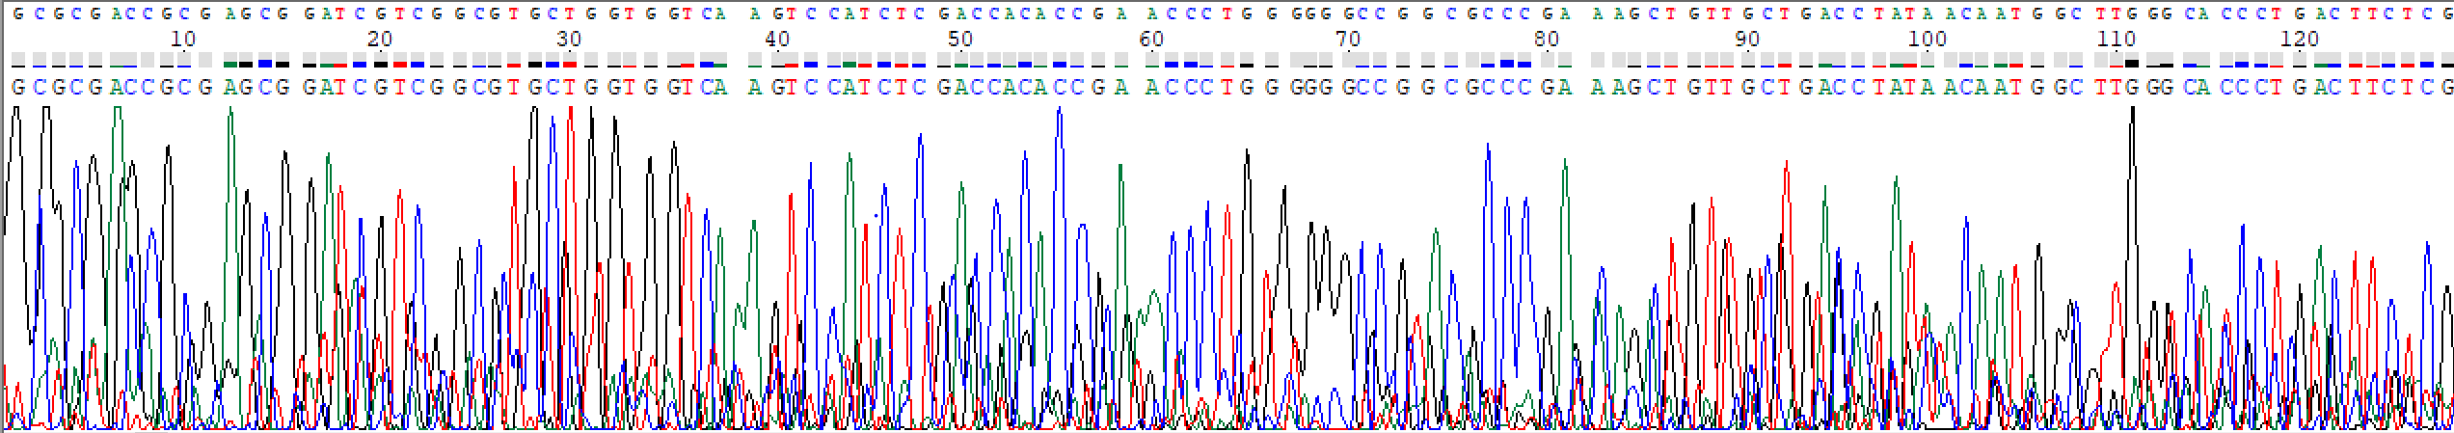



Fig 2: This figure shows the raw data obtained from the sequencing reaction. This reading contains the sequence of the transposon that was introduced into the bacterial cell’s DNA. It also contains the sequence of the gene that is being disrupted and flanking the transposon. This sequence reads: GCGCGACCGCGAGCGGATCGTCGGCGTGCTGGTGGTCAAGTCCATCTCGACCACACCGAACCCTGGGGGGCCGGCGCCCGAAAGCTGTTGCTGACCTATAACAATGGCTTGGGCACCCTGACTTCTCGGCCCGACTGTCGCTTCTGTGCTATC

After we obtained the reading and learned the genetic code of the gene that was being interrupted, we used NCBI BLAST database to compare this code to other genes in the database within the *P. putida* organism. The gene that we found that matched the sequence of the reading was gene *PP_0264* which is described in NCBI database as a sensor histidine kinase. This Is shown in figure 3.

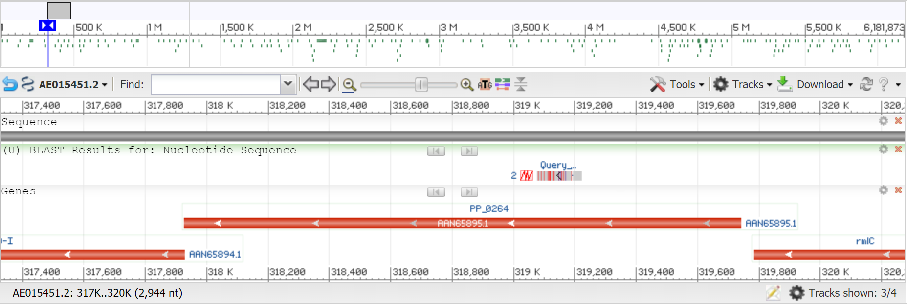

Fig 3: This figure shows the genetic placement of the gene *PP_0264* and the placement of the transposon that disrupted the function of the gene

**Discussion**

Not a lot is known in terms of how bacteria such as *P. putida* can metabolize unusual metabolites such as LA, but what is known is that the answer can be found in the genome of the organism. The complete genome sequence of the bacterium *P. putida* was published in 2002 (5), but this was back when the annotations of genes were not very great and the ability to study genomics was just becoming efficient. Now in the current years we can not only find and sequence the genes but we can also do studies to see how organisms react with or without these genes effectively figuring out the function of the gene. Since then more studies have been done into the genome of *P. putida.* Within this research more 242 new protein coding genes have been identified and over 1500 genes have been re-annotated (6). These genes may play an important role in industrial biotechnologies such as biofuels and the ability to create energy out of matter.

Because our mutant was able to grow on plates with kanamycin anti-bacteria, we can reasonably assume that the transposon was incorporated in the genome of the bacterium. This is because the vector did not have the ability to replicate on its own and must have used a polymerase that was interacting with the genomic DNA. Because our mutant was able to grow on glucose medium but not LA medium this indicates that most of the genetic machinery is working appropriately except an essential gene that is a part of the mechanism used to metabolize LA. In this study that genetic machinery or component is gene *PP_0264,* which is a sensor histidine kinase. This protein has not yet been intensively studied yet. I believe that this protein interrupts the bacteria’s ability to metabolize LA because it is a second messenger and without it the cascade is stopped short and the correct transcriptional mechanism to metabolize LA is not synthesized. We hypothesized that our mutant with the incorporated transposon will not be able to metabolize LA, and we believe it is because of this essential protein. Future research that this could uncover is the ability to do complex redox reactions that can be used to create novel biofuels. There millions of proteins database entries without reliable functions (7), many of those functions can be used to break down unusual metabolites such as LA.

Bibliography

1. Sharma PK, Fu J, Zhang X, Fristensky B, Sparling R, Levin DB. 2014. Genome features of Pseudomonas putida LS46, a novel polyhydroxyalkanoate producer and its comparison with other P. putida strains. AMB Express 4:1–18.
2. Rand JM, Pisithkul T, Clark RL, Thiede JM, Mehrer CR, Agnew DE, Campbell CE, Markley AL, Price MN, Ray J, Wetmore KM, Suh Y, Arkin AP, Deutschbauer AM, Amador-Noguez D, Pfleger BF. 2017. A metabolic pathway for catabolizing levulinic acid in bacteria. Nat Microbiol 2:1624–1634.
3. Harbor CS. 1953. INDUCTION OF Instability LOCI IN MAIZE BARBARA.
4. Kashefi, K. MMG 408. EXPERIMENTS I-III Experiment I: Bacterial Growth and Induction of Bacterial Operons, Bacterial Genetics Exponential Growth and Induction of the E. coli lac Operon
5. Nelson, K. E., Weinel, C. , Paulsen, I. T., et al. (2002), Complete genome sequence and comparative analysis of the metabolically versatile *Pseudomonas putida* KT2440. Environmental Microbiology, 4: 799-808.
6. Belda E, van Heck RGA, José Lopez-Sanchez M, Cruveiller S, Barbe V, Fraser C, Klenk HP, Petersen J, Morgat A, Nikel PI, Vallenet D, Rouy Z, Sekowska A, Martins dos Santos VAP, de Lorenzo V, Danchin A, Médigue C. 2016. The revisited genome of Pseudomonas putida KT2440 enlightens its value as a robust metabolic chassis. Environ Microbiol 18:3403–3424.
7. Bastard, K., Smith, A.A.T., Vergne-Vaxelaire, C., Perret, A., Zaparucha, A., De Melo-Minardi, R., et al. (2014) Revealing the hidden functional diversity of an enzyme family. Nat Chem Biol 10: 42–49